**NAME : Arshia Noonari**

**STUDENT ID : BIT-24S-008**

**DEPARTMENT : INFORMATION TECHNOLOGY**

**SUBJECT : ARTIFICIAL TECHNOLOGY**

**LAB:7**

**TASK:1**

**Write a function that takes two numbers and returns their product.**

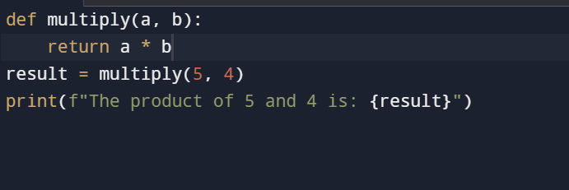

**OUTPUT**

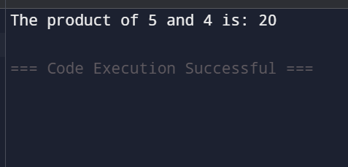

**TASK:2**

**Write a function that checks whether a number is even or odd.**

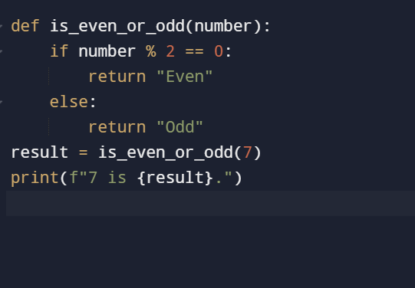

**OUTPUT**

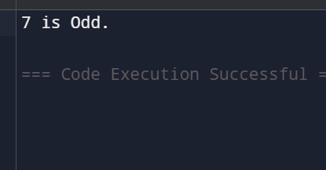

**TASK:3**

**Write a function that takes a name and age and prints a greeting.**

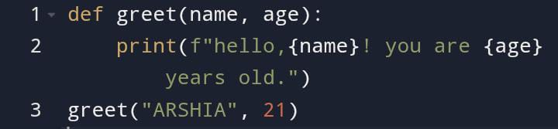

**OUTPUT**

